Mountain Brook

Presbyterian Church

*Living a Friendly Faith*

*“We love because God first loved us.” 1 John 4:19*

August 17, 2025

3405 Brookwood Road • Mountain Brook, Alabama 35223

www. mbpcusa.org • (205) 967-5037

**Prayer of Preparation**

God of Peace,

your call, at times, appears to divide us from one another.

Help us to overcome our fears and respond in courage.

Give us faith to trust the unity that is beyond our sight.

Give us your eyes to recognize the signs before us.

We ask this in the confidence of your Son, Jesus Christ

our Lord. Amen.

\**Please stand as you are able.*

**ORDER OF WORSHIP**

August 17, 2025

✠ **Gathering** ✠

*We* ***gather together*** *to praise God, confess our sins, and receive forgiveness in Jesus Christ.*

*We celebrate God’s gift by passing the peace and joy of Christ to our neighbors.*

**Prelude** *Allemande* J. S. Bach

**Chiming of the Hour**

**Introit** *Soon and Very Soon* Hymn 384

\***Call to Worship**Rev. Dr. Jim Truesdell

**\*Hymn 268** *Crown Him with Many Crowns* diademata

**Confession and Pardon** Isaiah Causey

Call to Confession

Confession of Sin

**God of hope, we confess**

**our disregard of your care,**

**our doubt of your providence, and**

**our blindness to signs of your love.**

**We are afraid to risk our comforts to find new life;**

**we separate ourselves from you and from others**

**and foster divisions between those you love.**

**Help us to amend our lives and make us your faithful people**

**who bear the good fruit of your Word in the world.**

**Through Jesus Christ, our Lord.**

(*A time of private confession)* **Amen.**

Declaration of Forgiveness

**\**Gloria*** *Glory to God* gloria (taizé)

**Glory to God, glory to God, glory in the highest!**

**Glory to God, glory to God, alleluia, alleluia!**

\***The Peace** Isaiah Causey

**Moment with Children** Isaiah Causey

*While the organist plays, children are invited to come up front for the Children’s Moment.*

✠ **Profession, Prayer, and Provision** ✠

*We* ***profess*** *what we believe**to God’s Word by stating what we believe.*

*We* ***pray*** *for our church, community, and the world.*

*We* ***provide*** *for our Gospel ministry to sustain God’s Kingdom work on earth*

*by offering our talents and tithes.*

\***Profession of Faith Apostle’s Creed** Rev. Dr. Jim Truesdell

**I believe in God, the Father almighty,**

**Maker of heaven and earth,**

**and in Jesus Christ his only Son, our Lord;**

**who was conceived by the Holy Ghost,**

**born of the Virgin Mary,**

**suffered under Pontius Pilate,**

**was crucified, dead, and buried;**

**he descended to the dead;**

**the third day he rose again from the dead;**

**he ascended into heaven,**

**and sitteth on the right hand**

**of God the Father Almighty;**

**from thence he shall come to judge the quick and the dead.**

**I believe in the Holy Ghost;**

**the holy catholic church;**

**the communion of saints;**

**the forgiveness of sins;**

**the resurrection of the body;**

**and the life everlasting. Amen.**

**Prayers for the People** Rev. Dr. Jim Truesdell

**The Lord's Prayer**

**Our Father, who art in heaven,**

**hallowed be thy name, thy kingdom come,**

**thy will be done, on earth as it is in heaven.**

**Give us this day our daily bread;**

**and forgive us our debts, as we forgive our debtors;**

**and lead us not into temptation, but deliver us from evil.**

**For thine is the kingdom, and the power,**

**and the glory, forever. Amen.**

**Offering** Rev. Dr. Jim Truesdell

Offertory *My Faith Looks Up to Thee* L. Mason

*Doxology lasst uns erfreuen

**Praise God, from whom all blessings flow;**

**Praise God all creatures here below; Alleluia!**

**Praise God above, ye heavenly host;**

**Praise Father, Son and Holy Ghost; Alleluia!**

*Prayer of Dedication

**\*Hymn 475** *Come, Thou Fount of Every Blessing* nettleton

✠**The Word** ✠

*We* ***hear the Word*** *of God read and proclaimed through Scripture, music, and preaching.*

**Prayer for Illumination** Rev. Dr. Jim Truesdell

**1st Reading** Psalm 8 (NRSV) Pew Bible p. 467

1 O Lord, our Sovereign, how majestic is your name in all the earth!

You have set your glory above the heavens.

2 Out of the mouths of babes and infants

you have founded a bulwark because of your foes,

to silence the enemy and the avenger.

3 When I look at your heavens, the work of your fingers,

the moon and the stars that you have established;

4 what are humans that you are mindful of them,

mortals that you care for them?

5 Yet you have made them a little lower than God

and crowned them with glory and honor.

6 You have given them dominion over the works of your hands;

you have put all things under their feet,

7 all sheep and oxen, and also the beasts of the field,

8 the birds of the air, and the fish of the sea,

whatever passes along the paths of the seas.

9 O Lord, our Sovereign, how majestic is your name in all the earth!

*Leader: The Word of the Lord.* ***People: Thanks be to God.***

**Anthem** *Eternal Life (A Prayer)* O. Dungan Dot Reinhart, soprano

**2nd Reading** Habakkuk 3 (NRSV) Pew Bible p. 812

1 A prayer of the prophet Habakkuk according to Shigionoth.

2 O Lord, I have heard of your renown, and I stand in awe, O Lord, of your work.

In our own time revive it; in our own time make it known; in wrath may you remember mercy.

3 God came from Teman, the Holy One from Mount Paran.

His glory covered the heavens, and the earth was full of his praise.

4 The brightness was like the sun; rays came forth from his hand, where his power lay hidden.

5 Before him went pestilence, and plague followed close behind.

6 He stopped and shook the earth; he looked and made the nations tremble.

The eternal mountains were shattered; along his ancient pathways the everlasting hills sank low.

7 I saw the tents of Cushan under affliction; the tent-curtains of the land of Midian trembled.

8 Was your wrath against the rivers, O Lord? Or your anger against the rivers,

or your rage against the sea, when you drove your horses, your chariots to victory?

9 You brandished your naked bow, sated were the arrows at your command. You split the earth with rivers.

10 The mountains saw you, and writhed; a torrent of water swept by;

the deep gave forth its voice. The sun raised high its hands;

11 the moon stood still in its exalted place, at the light of your arrows speeding by, at the gleam of your flashing spear.

12 In fury you trod the earth, in anger you trampled nations.

13 You came forth to save your people, to save your anointed.

You crushed the head of the wicked house, laying it bare from foundation to roof.

14 You pierced with their own arrows the head of his warriors, who came like a whirlwind to scatter us, gloating as if ready to devour the poor who were in hiding.

15 You trampled the sea with your horses, churning the mighty waters.

16 I hear, and I tremble within; my lips quiver at the sound.

Rottenness enters into my bones, and my steps tremble beneath me.

I wait quietly for the day of calamity to come upon the people who attack us.

17 Though the fig tree does not blossom, and no fruit is on the vines;

though the produce of the olive fails and the fields yield no food;

though the flock is cut off from the fold and there is no herd in the stalls,

18 yet I will rejoice in the Lord; I will exult in the God of my salvation.

19 God, the Lord, is my strength; he makes my feet like the feet of a deer, and makes me tread upon the heights.

To the leader: with stringed instruments.

*Leader: The Word of the Lord.* ***People: Thanks be to God.***

**Sermon** *Above All Else* Rev. Dr. Jim Truesdell

✠ **Sending** ✠

*We* ***leave the service*** *taking the peace and joy of Jesus Christ into the world.*

**\*Hymn 269** *Lead On, O King Eternal!* lancashire

\***Benediction** Rev. Dr. Jim Truesdell

**Response** *Soon and Very Soon* Hymn 384

**Postlude** *Prelude in F* J. S. Bach

**Congregational Meeting**:

A Congregational Meeting is scheduled for Sunday, August 31, immediately following the service, to elect an elder to fill the vacant position in the Class of 2027. The current nominee for this vacancy is Ron Morrison.

**Guest Pastor Spotlight**

Rev. Dr. Jim Truesdell has more than 20 years of experience pastoring churches in Mississippi and Alabama. As a pastor, he was passionate about helping his congregations participate in God’s work among the nations. Following a vision trip with Frontier Fellowship, his ministry trajectory changed course as he felt an impassioned call to the frontier. After a season of nurturing local congregations, he joins Frontier Fellowship’s staff to help mobilize churches to engage with least-reached peoples in South Asia.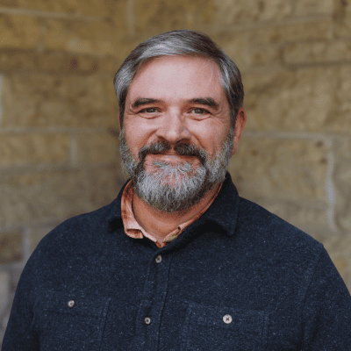

A dedicated and curious home cook, Jim is fascinated by how food is a powerful expression of community, social location and culture. In his free time, he also enjoys camping and backpacking. He and his wife, Sonja, have been married for more than two decades and have a teenage daughter, Emma.

**Childcare and Children**

During the worship service, children in Kindergarten through 6th grade, are invited to participate in Sunday School. They will leave the worship service after the Children’s Moment.

On Sundays when Communion is offered, children attending Sunday School will rejoin the worship service to receive Communion.

**2025 Acolytes**

| Avery Faircloth | Charlotte Kearse | Sara Turnley Robinson |
| --- | --- | --- |
| Beckett Faircloth | Paul Kearse | Tripp Robinson |
| Vera Johnson | Emily Kim | Rushton Robinson |
| Hazel Johnson | Audrey Kim | Jackson Robinson |
| Jesse Horton | Hosford Roberts | William Wellman |
| William Kaiser | Pryor Roberts | Katherine Wellman |
| Luke Kaiser | Carolyn Roberts | Mary Claire Wilson |

**Congregational Care**

The Congregational Care team is here for you! If you or anyone you know is experiencing hardship from death, illness, hospitalization, or anything else, please let us know.

We care and want to help!

| Diane Beck (205) 915-0903 | Karen Ogle (585) 267-6140 |
| --- | --- |
| Becca Roberts (404) 861-8387 | Bill Heslop (972) 743-3426 |
| Mindy Faircloth (919) 389-0038 | Katherine Robinson (205) 706-4506 |
| Molly Trueb (205) 540-5769 | Judy Wilson (205) 967-8935 |

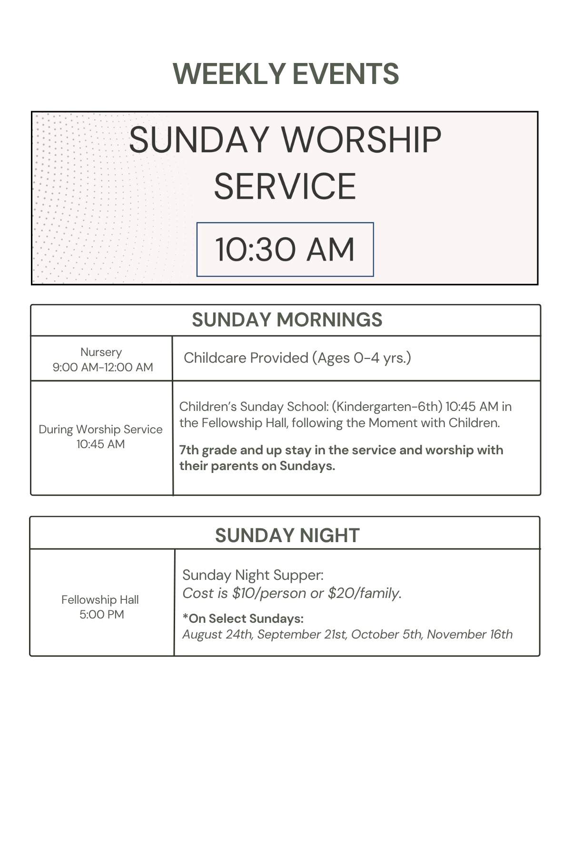

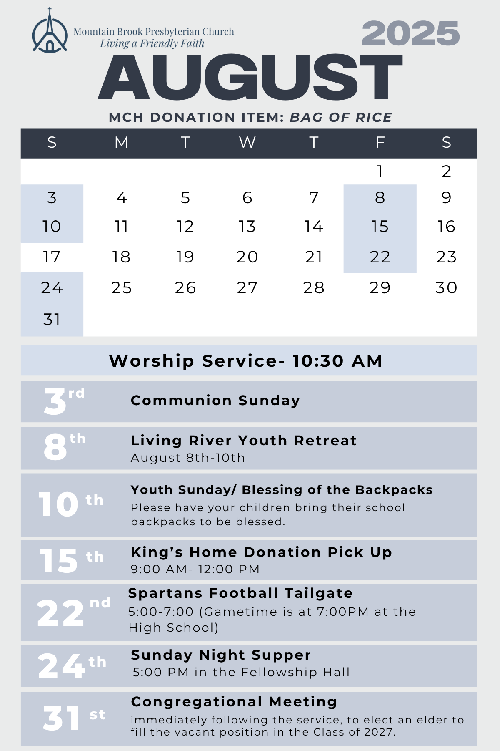



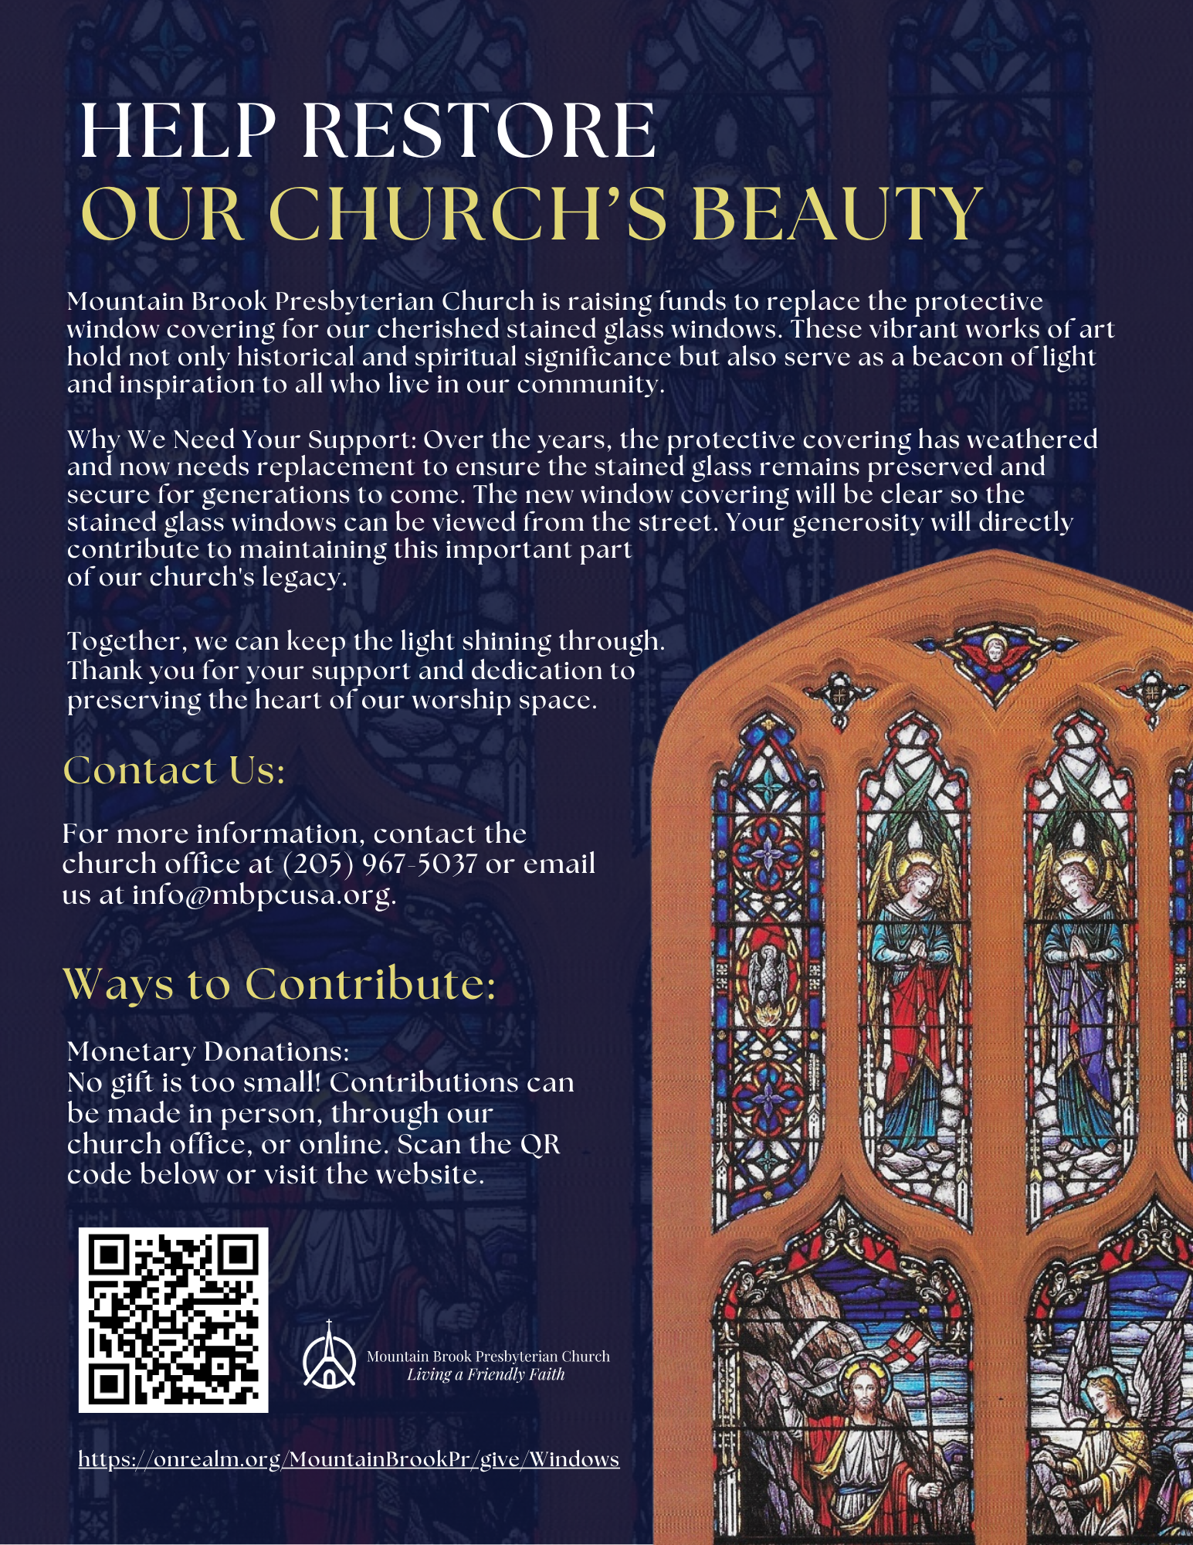

| | **The Staff** | | | --- | --- | | ***Pastor***  Rev. Madison Roberts  ***Director of Music & Organist***  Gary Smoke  ***Administrative Assistant***  Gabby Donohue  ***Boy Scout Troop 320***  Scoutmaster: Dave Caskey | ***Director of Youth***  Isaiah Causey  ***Director of Preschool***  Morgan Rogers  ***Children’s Choir Director***  Allison Sanders  ***Cub Scout Pack 320***  Cubmaster: Aaron Bennett | | |
| --- | --- | --- | --- | --- | --- |
|  |  |
|  |  |

**The Session**

The governing board of our church is called the “Session.” The current members of the Session are listed below. Please don’t hesitate to communicate with them about any matter concerning the church.

| **2025**  Ralph Cook  Bill Heslop  Jonathan Jordan | **2026**  Diane Beck  Debbie Crumpton | **2027**  Kelly Morrison  Katherine Robinson  Lisa Wilson |
| --- | --- | --- |

Please access the church website at [**www.mbpcusa.org**](http://www.mbpcusa.org/)

to view the church calendar and video of portions of our weekly services*.*

*Please drop your bulletin in the basket located in the Narthex as you leave the worship service,*

*or feel free to take it home and refer to it during the week.*

*Permission to reprint/stream the music in this service is obtained from ONE LICENSE*

*with license #A-726770. All Rights Reserved.*

**Welcome Visitors!**

We are so glad that you could join us today. We would love to get to know you, and if you would like to learn more about our church, please take a moment to fill out the form below. Again, welcome!

**Visitor Information**

Name:

E-Mail:

I would like to receive MBPC’s Weekly Email Newsletter (“Monday Mentions”)

Address:

State: Zip Code:

Phone:

Questions or Comments: